**Edward Mendell FRPS (1920 to 2007)**

Edward Mendell was an American businessman, who based himself in England after the Second World War. He set up a successful chemical company before focussing on his love of photography and became an accomplished international photographer. Mendell lived in Windlesham for part of his life before returning to America and California. He was both supporter and President of the Windlesham and Camberley Camera Club from 1995 to his death in 2007.

In 20 years he visited 50 countries, travelling to isolated tribal villages and discovering unique viewpoints of the animal kingdom. The threat of extinction to both tribespeople and wildlife forged his passion to document and photograph what he saw. He produced three major publications – Wildlife Odyssey in 1990, A Bevy of Beasts in 1993 and Tribal Odyssey in 2000.

His collection of photography was donated to the University of California. Surrey Heath Museum has over 60 of his prints in our collection and on display is a small selection; if you wish to see the whole collection, please book an appointment at the front desk.

*“In my reminiscences I travel to isolated villages in Ethiopia, on elephant back in Assam’s high grass forest, on a slippery glacier in Alaska – and in these moments I am free of my wheelchair; viewing the world through the viewfinders and lenses of my memory”* - *Edward Mendell*



Edward Mendell at work - waiting for Polar Bears in Alaska

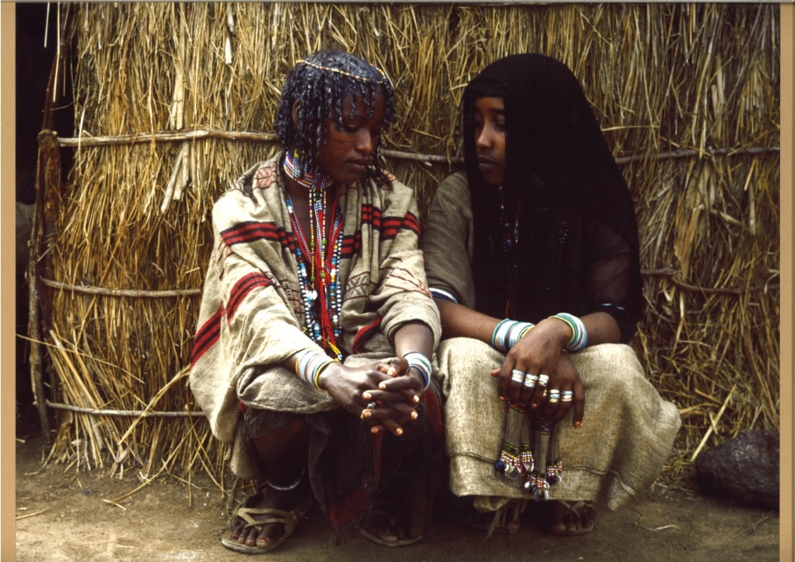

Kereyu Tribe, Ethiopia