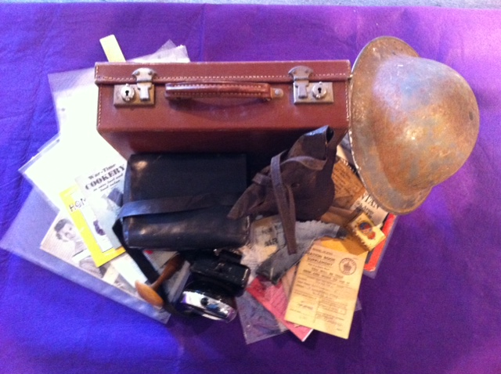
World War Two

General Information

World War Two in Europe began on 3rd September 1939, when the Prime Minister of Britain, Neville Chamberlain, declared war on Germany. He did this because Germany had launched an unprovoked attack on Poland and Hitler refused to abort his invasion of Poland.
The war involved many countries in Europe and in Asia. It eventually ended in the summer of 1945. It is estimated that 50 million people lost their.

Britain sent lots of men to fight in Europe, but the people left at home were also affected by the war. Germany sent aeroplanes over to bomb Britain’s factories and naval ports. These were called air raids and mainly happened at night. The German Navy also started to sink ships bringing food to the UK and so there was a food shortage. There was also the threat that German soldiers might invade Britain.
The British Government came up with solutions for all these threats. They set up the Civil Defence which included a Home Guard to defend against any German invasion. Air raid shelters were set up around the country and black out time was introduced so that the bomber planes could not see where the cities, factories and ports were as everything would look dark as if it was all countryside. Rationing was also introduced so that everyone had enough food and people were encouraged not to waste things and to reuse things rather than throwing them away.
Darning Mushroom
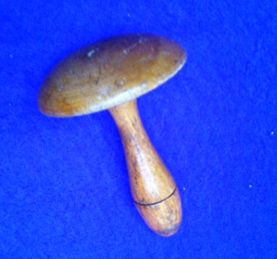

Darning Mushroom

A darning mushroom would have been found in every household throughout Britain. It was an essential tool for repairing items such as socks and other items of clothing made from wool or fabrics. Before the arrival of synthetic materials, socks and other items of clothing were in constant need of repair. Clothing was also expensive and was rationed in the war, so you would have had to repair old clothes rather than buy new ones.

Darning is a special sewing technique where the tread is woven into the garment. You would stretch the area which needed repairing over the larger part of the darning mushroom; this would make it easier for you to see the threads in the material.
Darning would have been considered a necessary skill for girls to have.

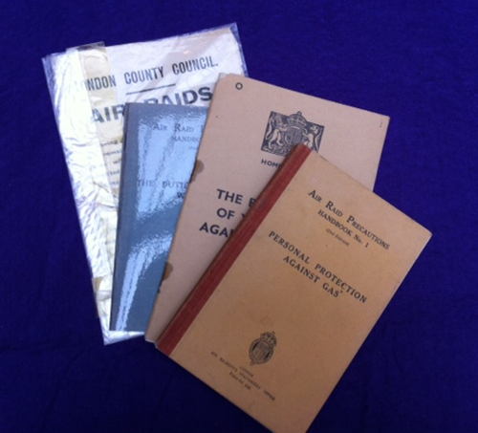
Air Raid Booklets
Air Raid Booklets

The Government printed lots of information booklets for the general public so that they could learn what to do in certain situations. The Government had learnt lots from going through the First World War, and so most of these booklets were printed before the Second World War started.

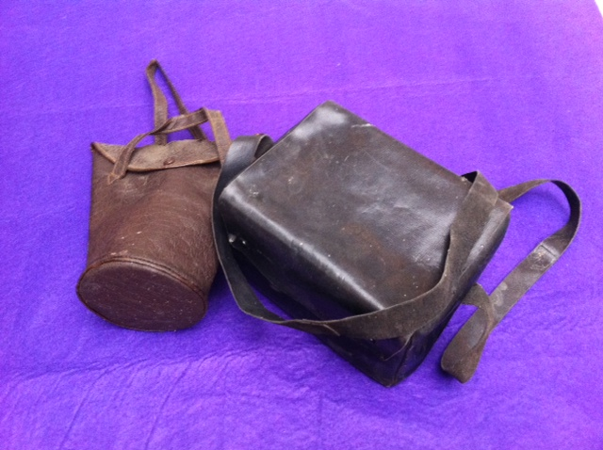
Gas mask Bags

Gas mask Bags

Everyone in Britain was given a gas mask in a cardboard box. This was to protect them from gas bombs, which they thought might be dropped during air raids. Gas had been used in the fighting in the First World War and so the British Government was worried that gas might be used on civilians; however this never actually happened.

Gas masks had to be carried with you at all times as you did not know when a gas bomb might be dropped. Because of this companies started making special bags to make carrying your gas mask easier.

These two bags used to contain gas masks, unfortunately the masks have rotted away. One bag was made to carry the government issued gas mask box in it as well, the other is designed just to hold the gas mask (you can see by its shape how the mask would have fit into it).

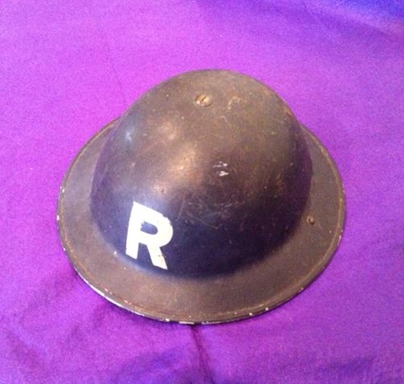
Helmet

Helmet

Helmets were issued to men who took up positions in the Civil Defence.
The Civil Defence were volunteer civilians who took on jobs to help the war effort. Jobs included Air Raid Wardens, Red Cross members, Fire Wardens and members of the Home Guard.

They were required to carry their helmets at all times and to be ready for duty whenever needed. Their helmet not only protected their head, but also made them recognisable to the general public.

This helmet would have belonged to a member of the Rescue Team. They would be the people who would try and rescue anyone trapped after a bombing raid.

Home Guard Letter
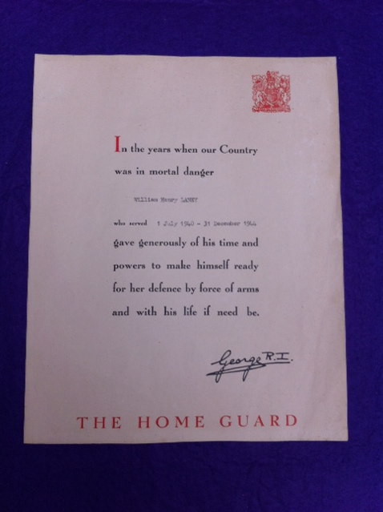

Home Guard Letter

The Home Guard was started to protect Britain from the threat of invasion. Many of the men who joined the Home Guard were those who could not join the regular army because their day time jobs were necessary to keep the country running. They included farm workers, bakers, teachers, grocers, bank staff and railway workers. Other men who joined were either too young or too old to join the regular army.

At the end of the war every Home Guard member received a certificate from the King, praising them for giving up their time to help out the war effort.

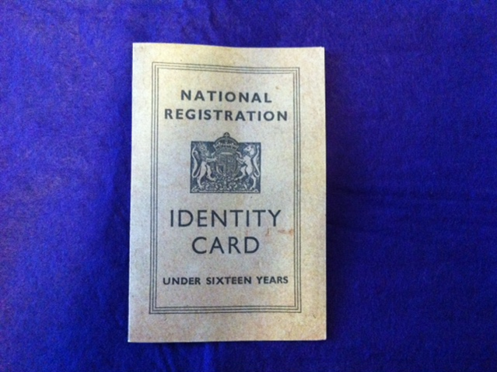
Identity Card

Identity Card

Identity cards (I.D. cards) were introduced during the War under the National Registration Act 1939. Everyone, including children, had to carry one at all times. This was so that you could show who you were in case families got separated. If people got killed by bombs they could be identified by the I. D. card on their body and I. D. cards could even be used to check that you were not a spy.
All I.D. cards were brown, but in 1943 adult ones were then changed to a blue colour.
Inside the identity card was the owner's name and address, including changes of address. The sections in the card showing the change in address were important, as many people moved several times during the war because of bombs and evacuations.
People had to carry identity cards wherever they went until 1952.

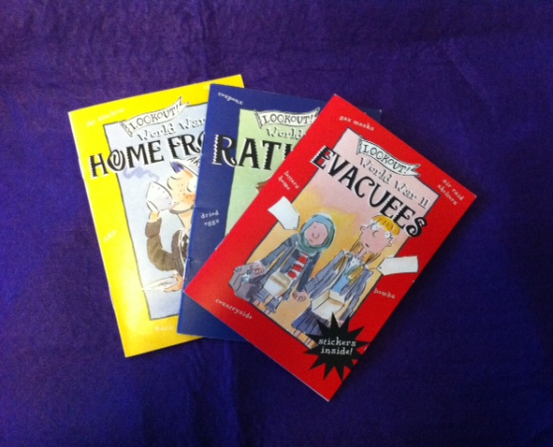
Information Booklets
Information Booklets

These booklets contain lots of simple information all about different things that were happening here in Britain throughout World War Two.

Bicycle Lamp
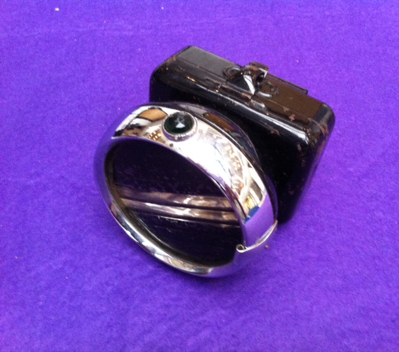

Bicycle Lamp

This bicycle lamp has tape over its light. It has been adjusted ready for a blackout. Blackouts happened throughout the war. This was when all lights were either turned off or blackout curtains were put up to stop light escaping from houses. This was done so that German bomber planes could not see where the towns and cities were when flying over in the dark.
However, lights were still needed on cars, buses and bikes when driving in the dark. So people taped up their head lights allowing only a small amount light to escape. This meant that driving in a blackout could be very risky.

‘Make Do and Mend’ Information
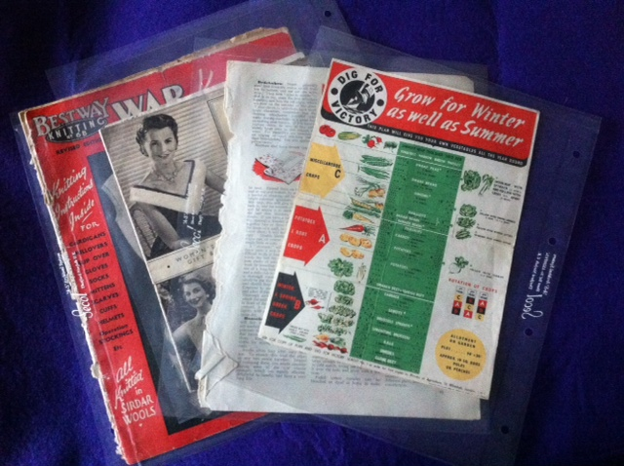
‘Make Do and Mend’ Information

It was very important in war time to use what you already had rather than buying new things. The wartime slogan ‘Make do and Mend’ encouraged people not to waste anything. With clothes rationed, it was a good idea to mend old clothes or to reuse them by making them into new ones yourself. Therefore many leaflets and articles were written which showed people how to repair things and make new things from old things. Sewing lessons were made available and people were encouraged to grow vegetables in whatever garden they had.

Newspapers

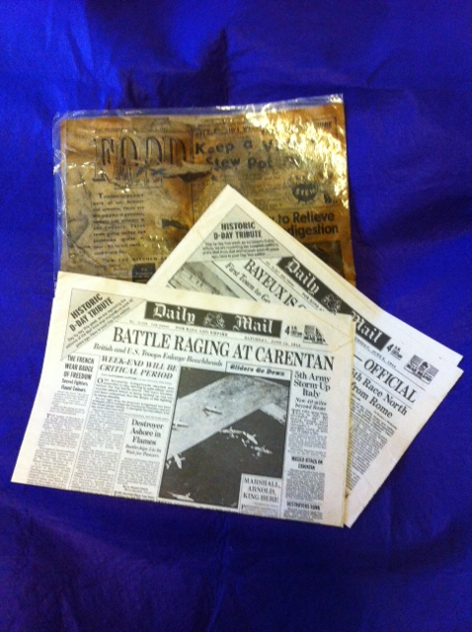

Newspapers

Newspapers were very important throughout the war because this was one of the very few ways people could learn about what was happening in Europe.

Here you have two replica newspapers which are copies of what was actually printed on those days back in 1944. The third newspaper is an original page from the Daily Graphic from 1941.

Rationing
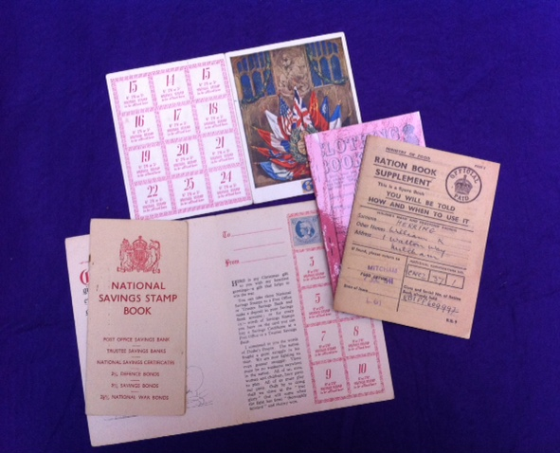

Rationing

As the war progressed it got harder and harder for Britain to import goods from overseas. This meant people had to live off things that could be grown and made in the country.
Because of this shortage of food and clothes the government introduced ‘rationing’. This was were people were only allowed to buy a certain number of items each month. It was done so that everyone got their fair share.

Things that were rationed were bacon, sugar, tea, butter, meat, cheese and eggs. Paper, clothes, petrol and other things, such as soap (one bar a month), washing powder, and sweets were also rationed.

Every household was given a ration book which contained tokens. You took these to the shops with you and handed over your tokens when you bought things. You had a separate ration book for clothing (as clothes rationing came in later), but you used tokens just the same.

Christmas cards were made which contained clothing stamps so that they could be given as Christmas presents.

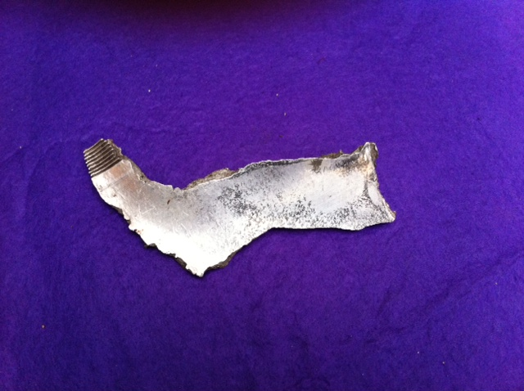
Shrapnel

Shrapnel

When a German plane crashed in Britain people often picked up shrapnel (broken off bits) as keep sakes. This piece of plane was collected from a crash site in Frimley Green.

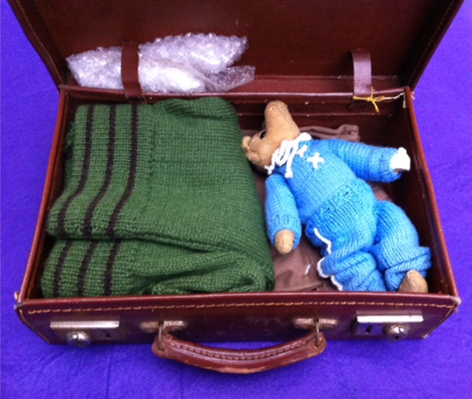
Evacuee’s Suitcase

Evacuee’s Suitcase

The Government was already prepared for evacuation and plans had been in place well before the beginning of the war. Bombs were expected as enemy planes would try to destroy factories, so it was seen as a good idea to move families away from this danger. School children and their teachers, mothers with children under five, pregnant women and some disabled people were all evacuated to the countryside, away from the major cities. They stayed with host families.

In September 1939 about 800,000 children left their homes. However, many returned home after a few weeks as no bombing happened. Later on many children were again evacuated when Germany started to drop bombs on Britain.

When children were evacuated they weren’t able to take much with them. They were sent off with their coat, their gas mask and a small suitcase full of items. Teachers sent letters home telling parents what to pack for evacuees: washing things, clean clothes, strong walking shoes and a favourite book, were some of the suggestions.
Activity Idea
Write a poem about one of our objects
Why not write an acrostic poem about one of the object in our loans box. An acrostic poem takes a word, and then uses each letter in this word to start a line of poetry.

- Write the name of the object vertically on the left hand side of the page.
- Start each line with a word that begins with the letter on that line.
- Each line should describe the chosen object.
- These poems do not need to rhyme, or have the same line length, so you can relax and have fun writing.

Then, why not draw the object next to your poem.

Activity Idea
Write a play which uses some or all of our objects

Why not write a play incorporating some or all of these objects. Then act it out using the objects as props.

Activity Idea
Make your own gas mask
Materials - You will need the following to make your mask:
- A3 piece of black card
- cellophane (any colour)
- bubble wrap
- elastic
- sticky tape
- scissors
Step 1: Mask outline  - Print out mask template.  - Cut around the mask outline and cut out the mouth/nose hole and eye holes.  - Trace the outline, mouth/nose hole and eye holes onto card using a pencil  - Cut out mask. | 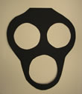
Step 2: Cellophane for eye holes  - Cut two circles of cellophane which are just a bit bigger than the eye holes.  - Sticky tape cellophane over the back of each eye hole. | 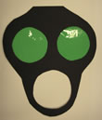
Step 3: Card for nose filter  - Cut a rectangular piece of card 30cm long by 5.5cm wide.  - Make into a cylinder, overlapping by approximately 3cm.  Sticky tape together.  The nose piece should fit the mouth/nose hole, not be bigger or smaller than it. | 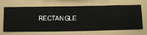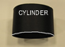
Step 4: Completing the filter and attaching it to the mask  - Cut two circles of bubble wrap which are the same size as the end of the nose filter.  - Stick one bubble wrap circle to one and of the filter cylinder using sticky tape and stick the other to the other end.  - Place the completed nose piece on the front of the gas mask over the mouth/nose hole and sticky tape it in place. It looks neater to have the sticky tape on the back of the mask. | 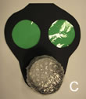
Step 5: Attaching the elastic  - Cut a piece of elastic 15 cm long. Sticky tape the elastic to the back of the mask halfway up the edge of the eye holes. | 