Name of assessor: Natalie Morgan Date: 01/07/2020
Work Area/Location: Museum & Gallery, 33 Obelisk Way, The Square, Camberley, GU15 3SG.
What is the hazard? | Who might be harmed? | How might people be harmed? | Existing risk control measures | Risk rating  L C R | Additional controls | New risk rating (Residual)  L C R | Action/ monitored by whom? | Action/ monitored when?
Covid-19  Possible Intruder/Aggressive behaviour towards staff  Pre-existing known medical conditions etc.  Fire  Out of Hours Working  Exhibit Stands | Staff,  Volunteers  and Public.  Staff and Volunteers  Staff and Volunteers  All  Staff  All | Risk of infection.  Physical threat. Theft of personal items and/or museum exhibits.  Staff falling ill without support.  Coming home late at night  Risk of falling on to visitors and volunteers | Staff aware of  Covid 19 risks & precautions to take.  Staff aware of emergency procedures.  Direct contact with Square and access to emergency procedures and contact details.  Staff should not confront the intruder.  Any medical conditions which might be relevant to working alone are fully discussed and documented with museum staff. Staff are not to work alone if any such condition is assessed is putting them at increased risk.  Museum staff are first aid trained. Security in The Square are trained and able to use the defibrillator.  All staff and volunteers aware of evacuation procedure.  ‘Buddy’ system to be set up. Staff to check in with ‘Buddy’ to inform home safely.  Regular monitoring of the area | High  Low  Low  Low  Low  Low | Sanitising Hand Gel, Facemasks, Wipes & Gloves provided;  Initial Deep Clean & regular sanitising of premises;  Disposable hand towels in toilet;  Sneeze Screens; Contactless Payments;  Information posters; Social distancing Controls;  One way visitor flows & reducing no’s entering;  Booking In system for researchers.  Signs in window stating ‘no cash held on site’.  All Staff have access to a phone. Access to phone and any mobile phones charged at all times.  Volunteer forms have two people that can be contacted in emergency.  Access to mobile phone to contact  Good housekeeping | Medium  Low  Low  Low  Low  Low | Museum staff  Manager on site  Museum staff  Museum staff  Museum staff  Museum staff and Volunteers | Ongoing  Ongoing  Ongoing  Ongoing  Ongoing  Ongoing

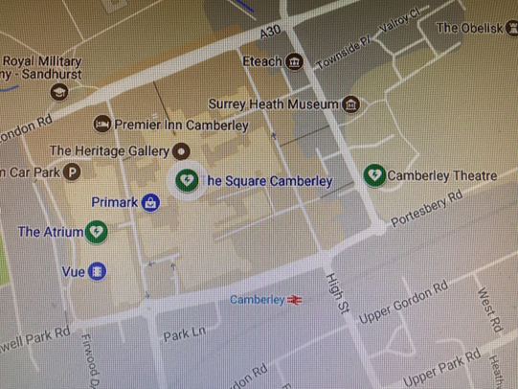
- Defibrillator Location: The Square Shopping Centre, GU15 3SL

- https://communityresponders.com/index.php/fr/about/local-pad-sites - Map website if needed.

- The Square Security telephone – 01276 24726

- Fire Evacuation: Ring the fire alarm at the side of the front entrance and move everyone out of the Museum. In the event of a fire alarm from another source move everyone out of the Museum and await instructions via the Mall public speaker. These will be given by the Mall Security within 3 minutes. A volunteer/member of staff must then go to the Muster Point across Park Street & down the slip way to the Service Area before the Atrium Car Park entrance to report that all are safely evacuated.

- Fire Blanket located in the Kitchen next to the Fire Alarm.

