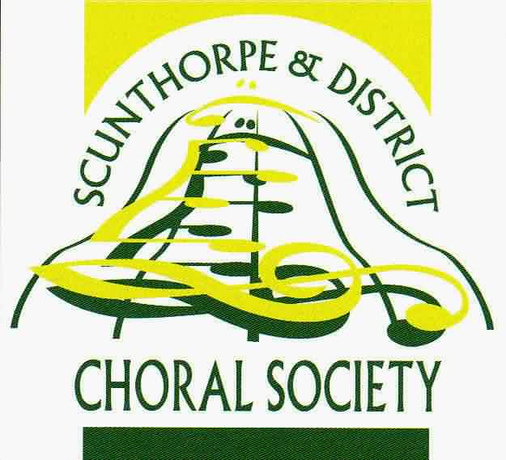
Scunthorpe & District Choral Society Medley

Your membership will be valid for a period of 12 months
Half of all monies received will be returned to winning Medley members via a monthly draw.

Your Details
Title: Mr / Mrs / Miss / Ms | First name: | Surname:
Address:
Email address |  | Postcode:
Telephone Number:

Payment £12.00
Cheque | BACS payment

The preferred method for payment is by BACS to:
Scunthorpe & District Choral Society,
Sort code: 30-97-44. Account No: 00155358

But of course you may also pay by cheque.
Please make cheques payable to Scunthorpe and District Choral Society.
and either deliver personally to Stephen Caldwell at a rehearsal, or post to Stephen Caldwell, The Old Mill, Melton Ross Road, Barnetby, DN38 6EB

Leave blank

Date Received:
Start Date: | Finish Date:
Medley No. allocated/renewed

