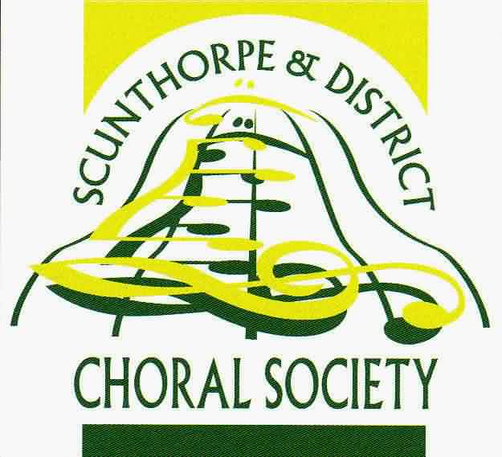

Scunthorpe & District Choral Society
Charity Number 504393
GIFT AID DECLARATION
Details of Donor:

Title………… Surname……………………….. Forenames…………………………………..
Address…………………………………………………………………………………………………..
……………………………………………………………………………………………………………….
……………………………………………………………. Postcode………………………………….
I would like the charity to treat all donations I have made since 1st March 2020, and all donations I make from the date of this declaration until I notify you otherwise, as Gift Aid donations. I am a UK taxpayer and I understand that if I pay less income Tax and/or Capital Gains Tax than the amount of Gift Aid claimed on all my donations in that tax year it is my responsibility to pay any difference.

Donor’s Signature……………………………………………………….

Date…………………
If you pay tax at the higher rate you can claim further tax relief in your Self- Assessment Tax Return. Please notify the charity if you cease to be a tax payer.

