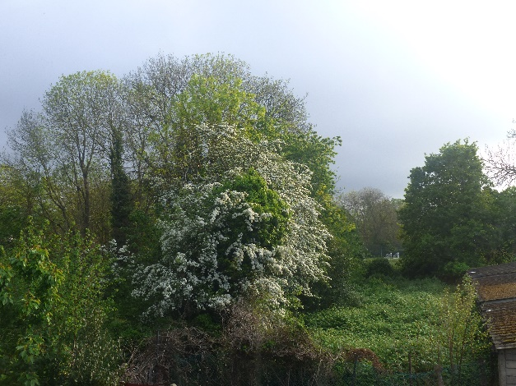
Dear Neighbours and Environmental Supporters,

Please consider supporting our request for a more robust TPO investigation after reading the below information and if you agree that this beautiful, wild hedgerow (growing on MOL) and some bordering trees which are an established habitat, visual amenity, dark space, line of navigation for bats/wildlife and more, deserves better protection from the threat of development in a totally inappropriate space next to an infant school and nursery.

Thank You,
River Crane Sanctuary

To: Council Tree Officer, Ecology Officer and Councillors,
Request for a TPO investigation for trees in the Wild Hedgerow behind Churchview Garages and Trees bordering Trafalgar Infant school

We attach a photo of the Hedgerow which has Hawthorn, Ash, Elder and possible Spindle Trees and the Oak at the border with Trafalgar School Playing field which we feel merit TPO status not only for their visual amenity but more importantly for their established habitat, (recorded red species birds, stag beetles, butterflies, bats) and location on the River Crane Corridor.

You are aware of the 'Mistake' by The Developers which destroyed the elder, ivy and self-seeded trees seen in the foreground of the photo attached, herewith, which the Council deemed would recover and which has not done so due to further spraying of the area. We do not want any more mistakes although, of course, maintenance is encouraged and especially in the area now allowed to run riot and cause potential damage to the garage block which needs to be kept in good order so it is used for its purpose to get cars off the road in this congested space and not parking with exhausts facing into Trafalgar School Play areas.

We feel a TPO is justified given the criteria set out by the Government on their website from which the below extract is taken:

A Tree Preservation Order is an order made by a local planning authority in England to protect specific trees, groups of trees or woodlands in the interests of amenity.

What does ‘amenity’ mean in practice?
‘Amenity’ is not defined in law, so authorities need to exercise judgement when deciding whether it is within their powers to make an Order.
Orders should be used to protect selected trees and woodlands if their removal would have a significant negative impact on the local environment and its enjoyment by the public. Before authorities make or confirm an Order they should be able to show that protection would bring a reasonable degree of public benefit in the present or future.
Other factors:
Where relevant to an assessment of the amenity value of trees or woodlands, authorities may consider taking into account other factors, such as importance to nature conservation or response to climate change
In some cases, the authority may believe that certain trees are at risk as a result of development pressures and may consider, where this is in the interests of amenity, that it is expedient to make an Order.

